Jonas Kadžionis
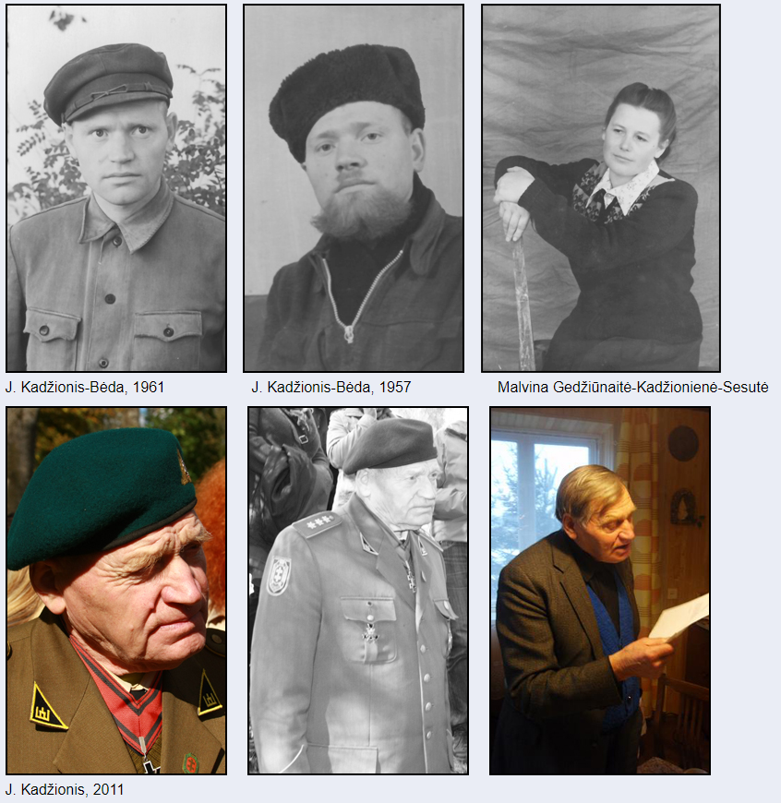
Biography

Jonas Kadžionis was born in 1928 in Piktagalis, Anykščiai district, Lithuania. His
parents Aleksas and Petronėlė Kadžioniai were farmers. There were 11 children in their
family. In 1936-1940 Jonas went to Pieninių primary school (Anykščiai distr.), he finished 4
grades. Jonas lived and worked in a family farm. At the beginning of the second Soviet
occupation in the spring of 1948 his parents were exiled to Siberia. Jonas Kadžionis wanted to
avoid military service in the Soviet Army so; he joined Lithuanian Freedom Fighters
Movement and became a partisan.
In 1948-1949 he was fighting in Tigras troop, Šarūnas pick of the army, Algimantas district.
His nom de guerre was Bėda (adversity). In 949-1953 Jonas Kadžionis- Bėda was fighting In
Laisvės (Freedom) district, he was one of three the last partisans in that district, he was hiding
in different dugouts in Kavarskas – Dabužiai – Traupis area. In 1949 Jonas Kadžionis got
married to Malvina Gedžiūnaitė. His wife Malvina Gedžiūnaitė-Kadžionienė-Sesutė (little
sister)(1923-1992) was a Freedom fighter, volunteer and an exile. In 1950 while Jonas and
Malvina were hiding in the dugout, their son Antanas was born. On the 22nd of May in 1953
Jonas Kadžionis –Bėda and his wife, partisan, Malvina Gedžiūnaitė-Kadžionienė –Sesutė by
guile were ensnared into an ambush and caught by the exterminator agents. In 1953 by the
Baltic Tribunal Jonas Kadžionis and his wife were sentenced to 25 years imprisonment and to
5 years exile. Jonas Kadžionis refused to appeal for pardon or admit that he was deluded, so
he was in prison in Russia the whole time of his punishment. At the beginning he was kept in
Omsk where he worked in the wood manufacturing factory, later he was building oil
conversion factory in Taishet, was in prison in Mordovia and in Perm, worked in the timber
mills.
After fulfilling his sentence in May, 1978 Jonas Kadžionis returned to Lithuania and settled at
his wife in Pajūris, Šilalė district, he worked as a cleaner in the church. The Soviet authorities
started pursuing him, he had been hiding for some time, was accused of freeloading and in
1983 exiled to Kaliningrad area, Russia, worked in the timber mill, in 1989 he retired. During
the years of Lithuanian Revival Jonas Kadžionis was allowed to come back to Lithuania and
in March 1989 he returned home.
On the 14th of April 1998 Jonas Kadžionis was recognised as Lithuanian volunteer, on the
13th May 1998 he was granted the degree of lieutenant. Presently Jonas Kadžionis is the
commander of the revived Algimantas district, retired captain and takes care of partisan war
monumentalization. He initiated the creation the memorial for Traupis district freedom
defenders, and marking partisan battle, death and burial places in Kavarskas area. He managed
to find the place of his former dugout in Dabužiai forest and in 2009 together with the other
enthusiasts reconstructed it. Nowadays the dugout is used for educational purposes.
Jonas Kadžionis was awarded the Cross of Commander (Third Class Order). In his free time
Jonas Kadžionis writes reminiscence, poetry and songs.
+ 1928 was born in Piktagalis, Anykščiai district, Lithuania
+ 1948 joined the partisans
+ 1949-1953 Jonas Kadžionis- Bėda was fighting In Laisvės (Freedom) district, he was one of
three the last partisans in that district, he was hiding in different dugouts
+ 1949 Jonas Kadžionis got married to Malvina Gedžiūnaitė. His wife Malvina Gedžiūnaitė-
Kadžionienė-Sesutė (little sister)(1923-1992) was a Freedom fighter, volunteer and an exile
+ 1953 Jonas Kadžionis –Bėda and his wife, partisan, Malvina Gedžiūnaitė-Kadžionienė –
Sesutė by guile were ensnared into an ambush and caught by the exterminator agents
+ sentenced to 25 years imprisonment and to 5 years exile
+ was imprisoned in Russia: Omsk Taishet, later in Mordovia and Perm (Russia)
+ 1983 exiled to Kaliningrad area, Russia
+ 1989 he returned to Lithuania
+ managed to find the place of his former dugout in Dabužiai forest, takes care of partisan war
monumentalization
+ awarded the Cross of Commander (Third Class Order)

The Baby Born in the Bunker
(The author of article: Laima Vince)

Outside of the underground bunker, the sky had grown dark with that thick as ink density that
settled in Lithuania in November and remained until the end of March. A light freezing rain was coming down along with a cold mist. But we were snug in the bunker with just an old kerosene lantern to provide us with a circle of light.
“I feel happy here,” Jonas Kadzionis said, a contented smile playing around his lips. Kadzionis
was seated on the dirt floor comfortably leaning up against a corner, as though it were the most normal thing in the world for an eighty-three-year old man to be spending his evening dug in underground in a bunker two meters long by two meters wide with a ceiling about a meter high, built from nothing more than rough wooden boards with a dirt floor. He was dressed in his partisan uniform. Last summer Kadzionis had organized a group of his old partisan friends together and they had rebuilt the bunker he and his wife had first built sixty years ago to hide from the NKVD after almost their entire unit of partisans had been killed. They had lived together here for three years, from 1950 until 1953 when they were betrayed and captured. Their only son had been born underground here in the bunker on the night of December 22, 1950. Jonas Kadzionis helped his wife birth the baby. No one else was present. The old bunker had sunk in on itself over the 25 years Kadzionis was away in hard labor camp in Siberia, but the new one was snug and tight and provided good shelter. Kadzionis was reunited with his grown son 25 years later, after his release from prison.
Ingrida and I were settled in the other two other corners, the third was occupied by a rough
wooden ladder that led to the escape hatch. The brilliant red Ingrida had dyed her illuminating her head drew out her playful brown eyes in the lamplight. Outside, above our heads, 25 history teachers were milling around a bonfire, singing partisan songs with Kadzionis’s friends, the surviving local Kavarskis region partisans. Ingrida had brought us here as part of a conference for teachers on how to use living history as a teaching tool in the classroom. Ingrida Vilkiene is the Education Director for the Center for the Study of Nazi and Soviet War Crimes in Lithuania.
“The people who would care for us in the bunker told us that on the night our son was born they
had both dreamed that a bright light was shining over the bunker,” Kadzionis said. Then he added, “Our baby was born with blue eyes, but when I saw him many years later his eyes were brown. Now, how does that happen?”
“It happens, it happens,” Ingrida said.
“Malvina nursed the baby in the bunker, but the baby rarely cried. We worried that maybe he
wasn’t well. We made arrangements for people to bring him to our relatives. Along the way, they got
scared and they abandoned him on the roadside. Good people found him and they raised him as their
own until he was nine. They loved him dearly and were very good to him. The NKVD suspected that the orphaned child these people were raising was ours, but they couldn't prove it. One time they ambushed the people's house. They shot up the house. Bullets entered the baby's crib, but the baby wasn't harmed.
“Wben Malvina came back from Siberia, she went and found our son. He was already nine years
old then. Although these people loved him, they gave him up when they saw what a good woman
Malvina was and how she loved him.”
Kadzionis half closed his eyes a moment, then opened them, recalling from the depths of his
memory the poem he’d composed on the night of the birth of his son. He’d held the poem in his head
during his long years of imprisonment and still kept it in his head, even now, sixty years later. He spoke
the poem for us as one would speak an incantation, or a prayer, with introspection and rhythm.
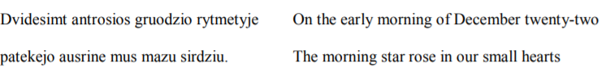
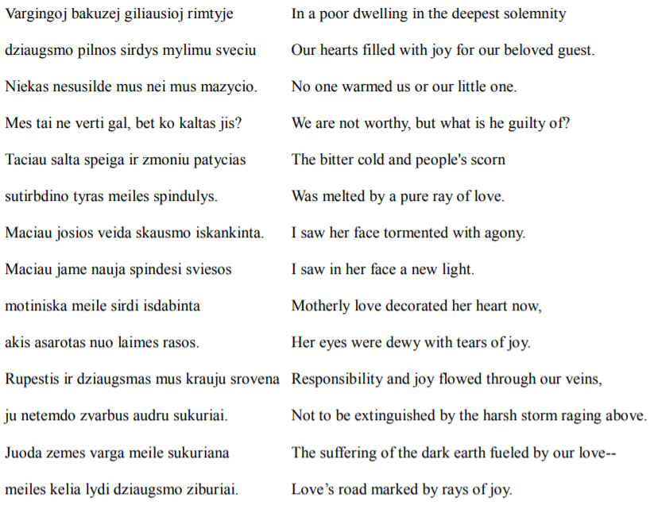
Jonas Kadzionis let out a long sigh. “Viskas ejo, viskas praeijo,” he said.
The closest idiom I could approximate in English is: This too shall pass.
I glanced at Ingrida. She was struggling to hold back her tears. We gave each other a silent nod.
That evening, before the three of us climbed the simple wooden ladder out of the bunker and
joined the others singing at the campfire, we agreed that Ingrida and I would return to Bebrunai Village to pull more poems out of Jonas Kadzionis's head and write them down.
It was late March and the days were still dark and dimmed by fog when Ingrida and I were finally able to break away from our busy schedules to spend a day with Jonas Kadzionis. Ingrida and I drove through the mud, wet, fog, mist, rain, of early spring to Kadzionis's village of Bebrunai in the county of Kavarskis. Here Jonas Kadzionis finally came home in 1989, thirty-five years after his arrest and sentence to hard labor. In 1989 when the law was changed and exiled Lithuanians were allowed to register to work and live in Lithuania. Of all the Soviet Republics, Lithuania was the only one that
would not let former prisoners of conscience or deportees register after their return from Siberia. Under the Soviet system, if you could not register, you could not work and you could not be allocated a place to live. There was nothing left for the unregistered to do but to become a burden to relatives or to settle in one of the other Soviet republics. Jonas Kadzionis and his wife Malvina tried living in Lithuania after he returned from prison in 1978, but they were continually hounded and pressured by the KGB to infiltrate the underground network of the Chronicle of the Catholic Church of Lithuania, which they refused to do. When that didn't work, the KGB began setting up “accidents” to finish them off. Within a few years the couple had no choice but to relocate to the Kaliningrad region.
After independence Kadzionis recovered the family land. He now lived in a small wooden
cottage in his native place. The cottage was surrounded by flat monotonous fields that disappeared into the foggy horizon. It had no indoor plumbing. An outhouse stood in the backyard, next to a dog house where a German Shepherd was tied up. In the living room religious images painted on cardboard hung on all four walls along with a black and white portrait of Malvina as a young woman. Throughout our interview Malvina's youthful innocent dark eyes gazed out at us. The face in the photograph was hopeful, idealistic, pure with a wry smile. Sweets, country sausage, and tea had been prepared for us in advance and were set out nicely on the pretty lace table cloth that covered the table. The table stood with an air of expectancy in the center of the room. The sofa was covered with neat woven cushions and blankets. For a widower living alone, the main room, the entire house in fact, was prim and tidy. Whenever Kadzionis came to a high point in his narrative, he would pause and recite a poem that he had composed and had held onto over the years in his memory. This habit of holding onto poems in one’s memory and not committing them to paper reminded me of the Stalin-ear Russian poet Anna Ahkmatova who had been forced by political circumstances to do the same. Composing poetry to mark important personal events had been a lifelong habit for Kadzionis from the time when he was a young man. He had never published any of his poems. In fact, he seldom shared them. He was just out of secondary school when he had joined the partisans and then had spent twenty-five years in prison for his partisan activities. He had no formal education beyond secondary school. All his life he had worked as a manual laborer. Yet, listening to his poems and his thoughts about poetry, I felt that under different circumstances, Kadzionis could have been a professor of literature.
“I have lived to see three miracles,” Jonas Kadzionis began, “and for all of them I am grateful and because of all of them I am satisfied with my life. The first is that I met and married the love of my life and that we were reunited after we were separated and sent to different prison camps. The second is that my son was born and that I found him again. The third is that Lithuania is free. That freedom is what it is: I am not happy that Lithuania is the way it is today. But the fact that independence happened took God’s miracle.”
“Tell us about your childhood before the War,” Ingrida asked.
“There were 13 people in my family,” Kadzionis said. “I had five brothers and six sisters. We lived on 25 hectares of land. In 1935 we went to live in a homestead. It only had seven hectares, but we began to live better. My sisters began to dress like the rich girls in town. There was no difference between them. The men in our family had shoes for winter and autumn. We had several pairs of men's shoes that we shared. I remember when I was small I ran around in bare feet, even in the winter. I'd run out to the well to fetch water and when I came back inside I'd heat my feet on the stove. Two of my brothers worked as farm hands on a wealthy farm, but my sisters did not work as maids anywhere. They were able to stay home.
“We only ate meat on Sundays. Otherwise, the meat was cut up and used for seasoning. We ate
lots of blynai and bread. You could say we were poor, but we were free and happy and we worked hard. I can't remember that we wanted for everything. We'd run all over the place. We were children of nature. There was very little money around. What we did have, we kept in a drawer. No one ever touched it. No one so much as ever thought of taking a litas out of that drawer. Mama handed out the money as needed to buy things for the family.
“In our house part of the floor was clay and the other part was wooden planks. Parts of the house
were not heated in the winter. There was no work for men in the winter. You'd twist yourself a rope and that was it—your work was finished for the season. Meanwhile, the women kept themselves busy as bees with their handiwork. In our village the men played cards in the winter.
“The house we lived in was in a beautiful place surrounded with forests. A pretty stream ran past.
We liked to pick mushrooms. We made money selling dried mushrooms at the market in Kavarskis.
We'd go half a kilometer to the forest. If you didn't get their early, everyone else got the mushrooms.
One time I asked my mother to wake me early. I wanted to get to the mushrooms first. It was still dark when Mama came to wake me. I was sleeping soundly and no longer wanted to get up. She dumped me on the floor. It was still dark when I went out into the forest to pick mushrooms, but I was first. I got the best ones. I went to the market with my mushrooms, but no one was buying. Money was a rare guest in our parts. A woman told me to go see the pharmacist; she knew that the pharmacist's wife liked to buy mushrooms. I went inside the pharmacy. I took off my hat. I felt unsure. Everywhere around me there were mirrors. I saw my reflection everywhere.
“I asked the pharmacist, Juozas Rimkevicius, if he would like to buy mushrooms. He called the
Ponia in. She had dyed hair. It was the first time I had seen dyed hair. She asked the price. I said, ‘Seven lits.’ She bartered me down to two. I told her about how early I had to wake up, about how hard it was to gather the mushrooms. She remained firm. The pharmacist told me not to go any lower. She left the room to bring me the two lits. Quickly, he pulled two lits from his cash drawer and handed them to me. He told me not to tell her. Then she came back and gave me two lits as well, so now I had four and that pleased me. Later, when I was a partisan, Juozas Rimkevicius would give us medicine and tend to our wounds.”
Jonas Kadzionis paused to enjoy a laugh over his mushroom story. But I thought about how
interconnected provincial societies were at that time. It took ten years of Soviet terror to tear apart the
tight-knit social fabric of the provinces.
“My brother Aleksas had been born in 1915, so in 1937 he was taken to serve in the artillery unit
of the Lithuanian army. While in the army he subscribed to the military magazine Karys (Soldier). The magazine came regularly to our home. We children would read it. Every issue had a section called “Our Brave Men,” which told the stories of the men who had fought for Lithuania's independence in 1918.
These stories told of incredible bravery against all odds. We were impressed with their courage. We
thought that anyone who didn't defend himself must be an idiot. We'd shoot off our mouths about how when the time came, we would defend our nation. And those times did come.
“Monika, my eldest sister, was already married. I often visited her. Her husband was an only
child and the Lithuanian Army did not take only children. In 1940 he had heard that the Russians had
come through the border. We were going somewhere in the horse and wagon. He said, 'Now they will
start slaughtering people.' My sisters would run and hide their heads under pillows when the pigs were slaughtered on our farm. Now my brother-in-law was saying that people would be slaughtered. My brother-in-law was an authority to me. I was 12 in 1940 and I took everything he said very seriously.
“I had some money saved. When I heard that people were going to be slaughtered, I thought, I'll take my money and at least for once in my life I'll eat a sweet meal before I am slaughtered. I can't remember drinking store bought tea at home. We only drank what we gathered and dried. Store bought tea was for guests only. And we had no sugar. That too was only for guests. Once my mother sent me to buy half a kilo of sugar. On the way home I stuck my tongue in it and my heart nearly melted. So that day, I decided, before I was to be slaughtered, I'd take all my money and buy myself all the candy I could possibly eat. I broke open the wooden piggy bank my brother had made for me and ran to the shop in town and bought myself a bag of candy. I stuffed myself on that candy. When I'd finished eating all the candy, I said to myself, 'Now they can come and slaughter me.”
Jonas Kadzionis paused and laughed long and hard and we laughed along with him. Even then he
had a sensitivity for words, I thought.
“We had one man in our village who joined up with the Communists,” Kadzionis said. “His name was Kostas Silvestras. He shot and killed a child and a young man. The women were afraid of him. They would hide their work on May 1st. When the Soviets started deporting people, they deported
two teachers from our village. We were children and we didn't really understand. I remember that these agitators showed up in our village shouting that we had to vote. But living in the village, we didn't really feel the effects of what was happening to the country. When the War began there was an uprising in Kavarskas. Now Silvestras went running to the men organizing the uprising, saying he wanted to join up with them and go kill Russians. No one believed him. They arrested him along with the other local Communists and locked him up, but they later released him, which turned out to be a mistake because he went and collaborated with the Germans and then when the Soviets came back in 1944, he joined up with them again.”
Jonas Kadzionis shook his head. “I remember my father down on the floor praying. He called out, 'Moc, where are our children?' He knew terrible things would happen. My father died soon afterwards, in 1941.
“When the Germans came to collect duty from our farm they sent in their police to search the farm. They measured how much land we had; how much grain. They counted the members of our family They wrote up a document stating that we did not have to donate grain as our family consumed as much as it grew.”
“What happened to the Jews in your region during the German occupation,” Ingrida asked.
“There were many Jews in Kavarskas. Their buildings are still standing today. They were built
well. The Communist Jews were hated because under the Russians they swore to us that they would
drink our blood. During the uprising, 16 of these types were shot in Kavarskas, but their families were left alone. Two Lithuanian men and their wives who supported Stalin were shot along with them. One of the woman shouted out, 'I die for Stalin,' before she was shot.
“There was no ghetto in Kavarskas. The Jews were shut up in their homes. One of the rebellion’s
leaders would order the Jews around. We called him King of the Jews. Everyone hated him. They took the Jews to Ukmerge and shot them there. Really, I can tell you for a fact that local Lithuaians
participated in the shoortings. From our village there was Gineitis, Sukovius and Juozas Mitusunas.
“Juozas Mitusunas and I were in prison together. He would say, 'I hate those Jew-killers.' I said
to him, 'You are a Jew killer yourself.' So he explained himself to me. He was young. The Germans
shoved a gun in his hands and forced him to shoot. He took one shot in the air, but he didn't kill anyone. He told me that there was a difference between men who were forced and those who had the intention to kill Jews.”
Kadzionis let out a long sigh. “The partisans would say, 'Zydsaudu kalte reikia nuplauti savo
krauju. We must wash away the guilt of the Jew-killers with our own blood.' The partisans never took those who shot the Jews into partisan ranks. Those scoundrels would try to join the partisans to hide from the Soviets. But the partisans would not take them. They were an abomination. I had many Jewish friends in prison. I was a veteran prisoner. I would try to help them. A great crime had been committed against Lithuania's Jews. The Jews had wisdom. Before the War, they took care of each other in the village. They never left one of their people alone in a difficulty.”
Ingrida broke into the conversation. “In 1941 a teacher came to my grandfather and said,
'Tomorrow we are going to go shoot the Jews.' My grandfather ran home, collected the family, and ran away during the night. He hid in many places during those years of the German occupation. The Jews were always foreigners in Lithuania. They were never accepted even though they’d been here since the 16th century. The Lithuanian Catholics would say that the Jews killed Jesus. People made their choices: whether to collaborate with the Germans or not.”
“Jews were cruel interrogators to the partisans,” Kadzionis said. “Seven percent of the
Communist party were Jews.”
“Seven thousand Lithuanans collaborated with the Germans,” Ingrida said, “and 7000
Lithuanians saved Jews. The numbers are equal.”
Ingrida knew her numbers. The holocaust in Lithuania was her area of expertise.
“The nations are not to blame: neither the Lithuanian nation for the genocide of the Jews nor the
Jewish nation for the deportations and torture of Lithuanians. Individual people are responsible and
those people must accept their responsibility,” Kadzionis said. He added, “If you are afraid to speak the truth, then you are guilty. The partisans made mistakes. Sometimes they inadvertently shot innocent people. That does not make the entire resistance wrong.”
“The Lithuanian government needs to take responsibility for what happened to the Jews in
Lithuanian,” Ingrida said, “Ninety percent of the total population of Jews were killed here. More than
anywhere else. The problem is that most of our current government is made up of people who committed crimes against humanity during the Soviet occupation. It’s only been 20 years.”
“All the KGB files have been removed from the country,” Kadzionis said, “We have no documentation. It is easy to attack us old partisans. The people who attack us know how to operate the propaganda machine, we do not. We are voiceless. The few of us who are left are dying every day.”
“In 1949 there were 20,000 informers in Lithuania working for the Soviets,” Ingrida said,
delving into more statistics, “and these people survived and established themselves in Soviet Lithuania.”
In 1944 the Soviets occupied Lithuania again, driving out the Germans. Jonas Kadzionis was
sixteen.
“My mother begged my brothers not to join the partisans in the forest,” Kadzionis said, “She told
them the Russians would destroy our farm and rip our family apart. I remember my two elder brothers were discussing what to do. 'I will sacrifice for my family,’ said my brother Karolis, ‘and I will join the Red Army.’Some men joined the Red Army voluntarily to save their families. They were sent to the front. You can’t hold that against them.
“‘No,’ said Kazys, ‘I am going into the forest to join the partisans and then we will be shooting at
each other.’
“So they both went into the forest. On February 9, 1945 Karolis was shot and killed in a partisan
battle against the Soviets. We were able to bring his body home and secretly bury it in the yard. At the time there was a bunker in our home where Kazys and other partisans hid. In July 1947 there was a large-scale operation all over Lithuania. The Soviet security forces combed the forests looking for
partisans. They surrounded our forests and entered our farm. My sister saw the Soviet soldiers
approaching from across the fields. She shoved a scythe in my hands and told me to go out and work the fields. I did, but too late, they caught me. They dragged me back to the house. They began interrogating us. They fetched our neighbor from next door to translate. They had figured out that she was the only one in our area who spoke Russian.
“The Russians told us that either we tell them where Kazys and Karolis are or they would burn
down our farm and shoot us all. We told them we did not know. They interrogated us until late in the
night and then told us they would return at nine the next morning. Mama got down on her knees and
began to pray, kissing the ground. My sister said Kazys had to come out of hiding or they’d burn him out of the bunker anyway.
“They burned our neighbor’s farms at that time. We saw how they took a young man named Tumas, rammed a pitch fork into him, and tossed him inside the burning building. They arrested another
young man they found hiding and they told him he could choose the spot where they would assassinate him, as though that was a humanitarian gesture.
“Mama told Kazys to go and turn himself in. He did. He sacrificed himself to save our farm.
They sent him to a Red Army training camp. I fell asleep that night and the same soldiers came back.
They invited the neighbor over. 'Where's your brothers?' they asked. We told them about Kazys and his registration. 'Where's the other one?' they asked. 'We don't know,' we said. I could understand Russian because my uncle had hid a Russian from the Germans on his farm. I'd learned some Russian from him. I understood when the soldiers told us they would shoot us. They cocked their weapons. They gave the command to burn our house. The neighbor fell on the floor at their feet. She begged them to wait. She told us to tell them where our brother was. She cried out, 'Save yourselves.' My mother made the sign of the cross. They were about to kill us. At the last possible moment, we told them we would tell them. We returned to the table. I told them that my brother had been killed. 'Where is he buried?' they asked. I wouldn't tell them. The soldier shoved his bayonet in my face. 'You bandit,' they said to me, holding the bayonet in my face, 'You tell us.' I told them nothing.
“Then they ordered me to go to Kavarskas and get documents for my brother Kazys, although they had sent him there themselves. I began to walk Kavarskas, but then ran when they could no longer
see me. I ran the entire way barefoot and I got his documents. We thought it would be enough, but again they demanded to know where Karolis was. Again we wouldn't tell them and they left.
“At night they came back and they found only Mama at home. They frightened her. They took her behind the barn and demanded to know where our brother was. She said, 'Here, under the cross.'
When we came back and she told us she'd told them, we were horrified. We said, ‘Mama, now they are going to dig him up and toss his corpse on the market grounds.’ She was so frightened, her hair began to fall out. They came back the next day and began to dig. They got as far as the coffin. They poked at it, but they didn’t bother dragging it up out of the ground.
“Because of Karolis’s corpse, the following year they deported our entire family to Siberia. My
family were declared ‘Enemies of the State.’ They took seven from our family: Mama, my brother
Antanas, and my sisters: Brone, Kazione, Petrute and Palmyra. They took them away barefoot. They
made the entire journey to Siberia barefoot. Fortunately, one of my sisters had the foresight to grab some shoes and clothing and stuff it into a suitcase as they were being taken away. They traded that clothing for a cow in Siberia and the cow kept them alive. My mother and two sisters were unfit to work, and that meant they received no rations. They would have died if other people hadn’t helped them. My mother was illiterate, but she managed to dictate one letter to me and have it sent from Siberia. Her words to me were: ‘My child, try to die in Lithuania.’
“I was on the deportation list, but I was not home when they came to take our family away. It
was May 22, 1948. I was away building a house for a farmer. I was 20 and I wanted very badly to join the partisans. I was worried it would be all over before I had a chance to join. The night they arrested my family, I had a terrible dream. I woke up to a beautiful May morning. People came and told me my family was gone. I cried so hard. The people I was working for brought me inside, served me breakfast, paid me the money they owed me. That day I made arrangements to meet with the partisans. A few days later, May 25, 1948, I joined the partisans.
“I remember that day I joined the partisans. I went out into the forest and two partisans emerged
out of nowhere. One had long curly hair and the other a big brown beard. They brought me back to their camp. They explained about code names and suggested I chose a code name for myself. I told them “Beda” (trouble).
‘Why such an ugly code name?’ the one with the beard asked.
‘Because I have egzema all over my body and it torments me. It’s real trouble,” I said.
They all laughed and immediately the name stuck.
“In 1948 our group of partisans did not fight at all. We were betrayed and surrounded. The Red Army soldiers would arrange themselves in tight lines and work their way through the forests searching for partisans by poking the ground with long poles, searching for underground bunkers. Sixteen of our
group tried to escape out of the forest at night. We had to get through water-logged fields. There was a full moon. We managed to get out. That time we passed a farm where there was a barn full of Russians. They saw us, but did nothing. I guess they didn’t want to risk getting killed themselves. The next day the soldiers combed the forests, but we were not caught.
“In 1949 there was another large-scale manhunt. Three of us died that time and in the end the
only three partisans left from our unit were me and Malvina, and one other man. I had been running a
fever of 40. I was not fully well, but I was afraid of getting caught, so I made an attempt to escape the
forests with my comrades. At one point they surrounded our small group on top of a hillock. I put my
pistol to my head. I was not about to let myself be taken alive. I was just about to pull the trigger when my commander called out to me from the bushes along the edge of the hill.
“‘Let’s try to make a run for it,’ he said.
“He indicated for me to roll down the hill with him.
“We both rolled down the hill, but we were still not out of danger.
“My commander said to me: ‘We’ve never been in such a hopeless situation. Let’s shoot ourselves now while we still have ammunition left.'
“Now, all of a sudden I no longer wanted to shoot myself. A new spirit took me over. I calculated
that we could take down a few of them before we were killed ourselves.
“‘No,’ I said, ‘let’s try to make it out alive. Let's go down fighting.’
“We made a run for the road. No one shot at us. We crossed the road and escaped. We crawled our way out of the forest along the road. We made it past two machine gunners. The local militia were
afraid to fight us. The Soviet soldiers saw us, but they were too lazy to shoot. Later there was a shoot-out and the commander and two other men were killed.
“The Soviets officially called that operation: Operacija Praval. A complete failure.”
We took a break to have some tea and give Jonas Kadzionis the opportunity to rest. After about
ten minutes, Kadzionis asked shyly, “Would you like to hear a love story?”
Ingrida almost jumped out of her chair. “Ponas Jonas,” she exclaimed, “we're women! Of course
we want to hear a love story.”
“In my youth, young people were brought up to be honorable,” Kadzionis said. “You made a
promise to a young woman and you married her and you were loyal to her. And that was it. When I was young, I never once met a family that was divorced. Never. Loyalty and respect towards women were emphasized in families. I was brought up to respect women. And the girls were good too. They were very loyal, helpful, cheerful. Young people would socialize in large groups. We would walk the country roads, singing together.
“When I became a young man, Mama said to me, 'Son, never act like a dog!'
“Me, act like a dog? I was hurt by her words though I understood what she wanted to tell me.
“That was why I was surprised when one day Mama came to me and said, 'There are three lovely
sisters on a farm in the next county whom I’d like you to meet.'
“I was surprised. Mama had just told me not to act like a dog and now she was telling me to go
see these sisters as far away as another county. I did not go then, but later I did. The eldest of the sisters was a liaison girl. When I did go there and I met the sisters under different circumstances, I was struck by the spirit of the eldest sister. I understood then why my mother had sent me there, but my mother was gone already, to Siberia.”
Jonas Kadzionis paused in his narration. “I don't write down my poems,” he said. “I keep them in
my head. These days I'm trying to write my memoir. When I remember a poem, I write it down.”
Kadzionis leaned back in his chair and closed his eyes. After a moment, his voice rang out in the
small parlor:
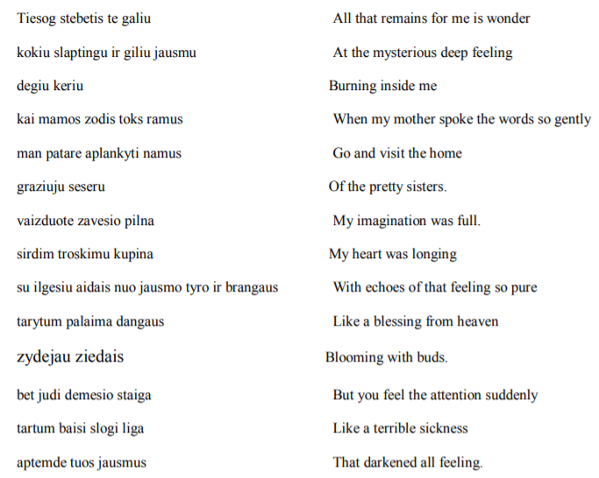
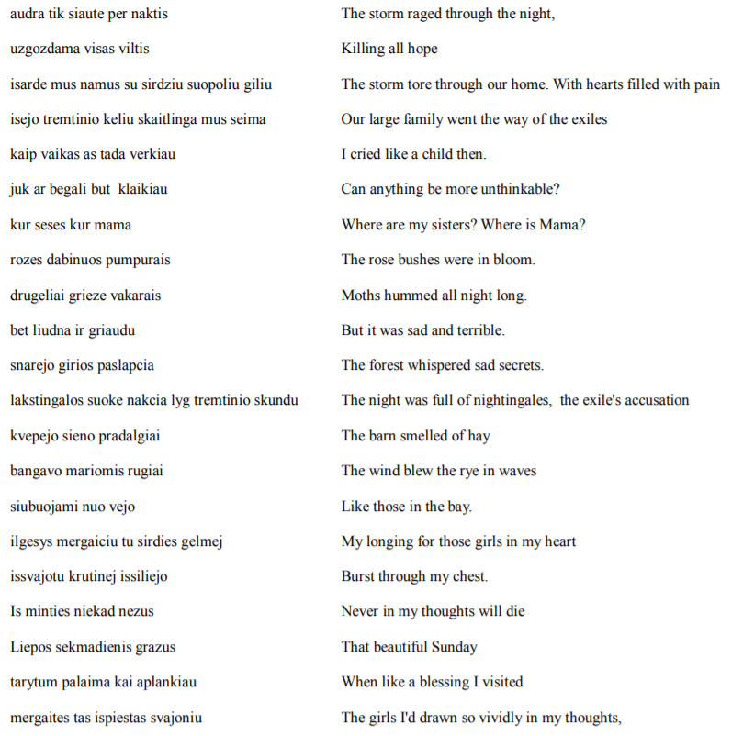
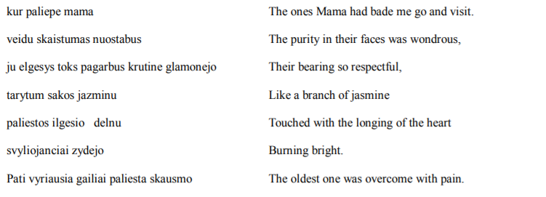
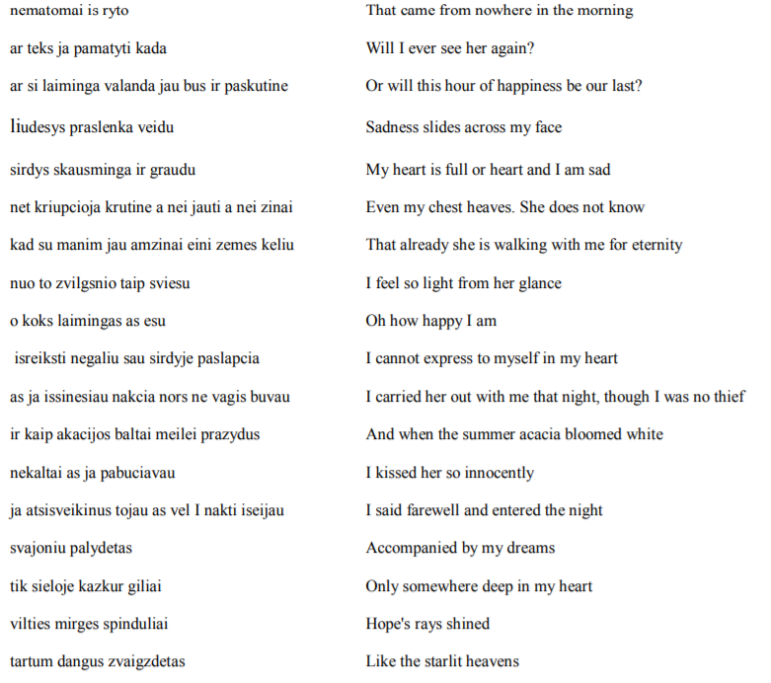

“That night Malvina was crying over a dead partisan whose corpse had been tossed out on the
market grounds.”
Kadzionis paused. “I want you to understand what a spirit my wife had.” He stood up and went
to the cabinet against the pull. He pulled out a letter.
“She wrote me this letter from the hard labor camp on the occasion of Lithuania’s prewar
independence day, February 16, 1956.”
He read:
“1956 February 16 from Irkusk region 11 latpunkt.
“Today is February the sixteenth. A day that is so beautiful. We worked in the forests today. The
forests around us remind me so painfully of Lithuania. The tall pines remind me of our tall pines. They remind me of the 100 year old oaks in Lithuania and of how they sway in the wind. The pines remind me of the fallen partisans, of their final breaths, and of their pain. We must in our prayers remember those who gave us the opportunity to be able to decorate ourselves with the Lithuanian tricolor flag, tofly the tricolor flag on top of Gediminas castle in Vilnius. And so we return back. How much all that has cost us. All the crosses of the dead who sacrificed themselves. How many mothers, babies, sisters, brothers, how many tears and suffering. How many painful sacrifices there are on the altar of those who sacrificed. Remember those who began this resistance. Today there are so many new crosses. How much suffering we have lived through. We tasted it. It is our duty. It is as it should be.”
Jonas Kadzionis set down the letter beside a black and white photograph of Malvina when she
was young.
“This is the real thing,” he said, “I never compromised. Not even in the shadow of my thoughts.
They tempted me. When I was in prison they said, 'Write a a letter saying that you were young, that you were misled, and we will let you go home.' My wife and I loved each other so much. We got along so well together. We wrote to each other all the time. They told us then we could go home. But I couldn't do it. I told them, 'I can't. You are the ones who committed the crimes. I can't admit to them.' They said to me, 'Then you will never see Lithuania again.'
“Vytautas Kazys was my interrogator. He said to me, 'If you speak this openly to me, then I can
imagine how you will talk to other people. You are dangerous.'
“I say what I think openly and I always express my opinion,” Kadzionis said. “Under the
Soviets they made you think one thing, say another, and do something else. I never was able to change myself to become that way. Many other people did and they thrived under that system.”
“You are brave,” Ingrida said.
“We really felt that the truth was on our side. But knowing that the truth was on our side did not
mean that you wouldn't die in the concentration camp. That was my biggest fear. To die on foreign soil.”
“But back to the story of how I married my wife,” Kadzionis said. “You remember we escaped
the ambush in 1949. That night there were two of us left and we were looking for a place to hide. We
found a barn near the road and decided to hide there. I told my friend, 'Wait, let me make us a nest close to the wall.' I went and started to build the nest in the hay. I reached out and grabbed a foot. It was her!
She knew that we were partisans. She heard us whispering. She asked if we were wounded. I told her no.
My competition left that evening for another bunker and the two of us remained. We agreed that we
would marry. The priest had told us partisans that life must go on. That if a partisan man and woman
gave each other their word, they could marry in the forest and later go to church to formalize the
marriage when the war was over. That night in the hay loft we married ourselves. Our wedding date is:
August 21, 1949.
I composed a poem for the occasion called, “Gyvenimo Iskilmes” (The Ceremonies of Life)
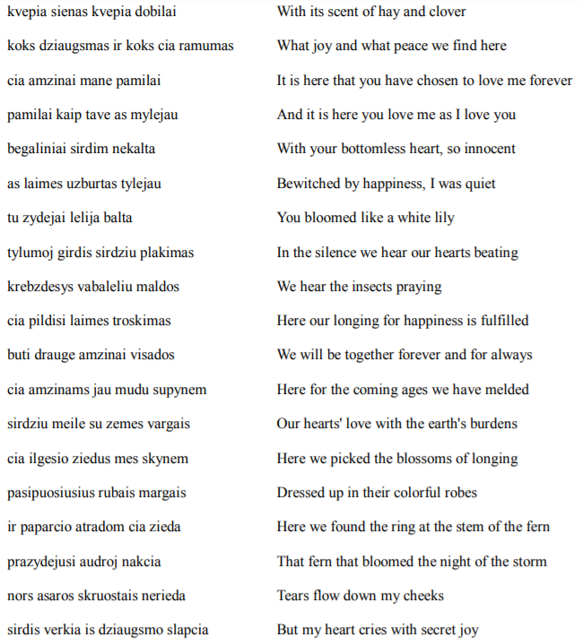

“After our wedding night, I went out to find a new place for us to hide. I would have run right
into the arms of the KGB if I hadn't run into one of my sisters first. I said to my sister, ‘Bring me
Silvestras,’ thinking he was now on our side. She said, 'My child, he is the one who betrayed you.' If I had gone to find him my honeymoon would have been over immediately. It was not fated to be so.
“I always felt the finger of god. Once I behaved in a sacreligious manner. We stopped at a farm
and the farmer's wife said to us, 'You men are men, but why are you dragging this poor girl around with you?' So, after that in the bunker, in front of our unit leader, I said to her, 'Malvina, you have documents, you should go. We will die anyway, so why should you die with us?' She thought that I was completely serious and she began to cry.
“Jonuk,” she said, “my place is with you, at your side, and if that means lying dead in a ditch
together, then that is how it is meant to be.”
“And I felt terribly guilty,” Jonas Kadzionis said, “because in my heart I knew that I was just
saying it to test her. It was the one time I was cruel towards her.”
Jonas Kadzionis paused and a pained look passed across his face.
“It is not nice to say this about men, but it's true. When times are hard, women are stronger. A
man will betray you, but a woman will never betray you. I've never heard of a woman betraying our
fight. Men sometimes will betray each other. It's not nice, but true, I know. If a woman makes a
commitment to something, then nothing will break her resolve. How many liaison girls sacrificed their lives for our cause. The prisons were filled with young women. They wrote poems and songs. The whole nation rose up and they did it voluntarily. It should be clear that this was the will of the nation. Young people sang only partisan songs. They would hide the lyrics, copy them, pass them on. It was massive movement. Everyone was involved. All those young women wrote, sang, healed, sacrifice. I can't explain it to you. It is beyond the scope of imagination. It was a total feeling of unity.
“There was one time when we were surrounded on top of a hay stack. Other partisans, without
knowing we were hiding there, took the grain away from that collective farm. Soviet forces began
searching the area. We heard someone tearing at the hay, then it got quiet. The farmer's wife came and told us that the Russians had been there. She showed us where they had poked at the hay. She told us that they were coming back to search all of the hay. We had no way out of the situation. The area was surrounded and we couldn't get out and past them. I thought to myself, if they return, then I will still try to shoot at least one of them. I would ask Malvina if she wanted me to shoot her or not. I really would have shot her. The stress is so great that under the circumstances a person is capable of that. Almost everyone was dead at that time. Everyone wanted to live, but almost everyone was dead already. But I did not have to ask her that day. They never came back. We all wanted to have someone who we could rely on in a tough spot; someone who we knew would shoot us in a difficult situation. No one wanted to be taken alive. We knew we would be tortured and there was the danger of betraying somebody else under torture. No one was quite sure if they would be able to manage to endure the torture. And so there it is, I have told you I would have shot the woman I loved so dearly if that meant saving her.
Jonas Kadzionis's life was the stuff of Shakespeare: In a moment of compassion, he could have
shot the woman he loved and it would not have been murder.I thought of Shakespeare's Romeo and
Juliet. I'd just finished reading and analyzing the play with my students. We'd had long discussions in
class on the nature of love, on the concept of duel suicide within a modern-day psychological construct.
One of my students had written on his exam in response to a question asking whether it was true love
that compelled Romeo and Juliet to commit suicide: “In order for someone to take their own life for the
sake of another person, that person's love and commitment must be true and deep and serious. Therefore, I believe it is love that prompted Romeo and Juliet to commit suicide and no other emotion or psychological disorder.”
“Tell us about your betrayal,” Ingrida said. “You were betrayed by Smogikai weren't you?”
“Yes,” Jonas Kadzionis said, “by my unit commander Mykolas Jaunulis, codename Tautvydas.
But I am not angry with him. I had written him a letter myself. What I did not know was that he had
already been arrested and was in the hands of the Smogikai. The letter I wrote went directly to them: It was too easy. They brought my letter to him. They ordered him to write back to me. I remember his
letter as though it were yesterday. In his letter he thanked God that we were still alive and well. He
hoped that we would be able to continue the fight we had started. He wrote that the new leader of the
Sarunas Rinktine had come to visit and he would like to meet to discuss liaison details. The meeting
would take place on either the 21 – 22 of May, 1953. He gave two dates in the event of unforeseen
events. He ended the letter, 'Until our pleasant meeting, good bye.'
“Suggesting two meeting dates was very clever. They didn't show up on the 21st. I was
disappointed. That made me more eager and anxious not to miss them on the 22nd. The night of the 21st I dreamed that a very long snake with two heads slithered up to me and bit me in my right arm and then my left arm. Then it wound itself around me into a stranglehold. The next day I ignored the dream and went to the meeting.
“Malvina and I went to the agreed-upon farmstead to wait for them. We saw them coming from a
distance across the fields. I remember it all so clearly. Over the years, I've gone over every detail in my mind. They came and we greeted each other. Everyone kissed each other as was the partisan custom.
When I went to kiss Tautvydas, he turned his cheek away from me. If there hadn't been a
misunderstanding between us I would have understood that he was trying to give me a sign that he had been taken alive, that his heart wasn't in the betrayal. You see, after he had stayed with us in our bunker, he wrote us a thank you letter. He wrote in that letter: 'You did a bad thing by going out and visiting our people.' My feelings were hurt. I wrote him a letter challenging him. I wrote that I never went out to visit other people. I wrote that I was hurt that I'd been falsely accused of behavior that was not worthy of a partisan. I had to write it for the record. What if I died and his letter was found accusing me and there was no reply in defense? What then? So, that day, when he turned his cheek away from my kiss, I thought that he had turned away because his feelings were hurt by my letter.
“The liaison asked if we wanted a shot to drink. Someone in the forest was brewing vodka, he
said and he had got some. They brought out a table and set it down. My turn came to take a shot and I
told them I didn't want any. I told them I'd go take guard, but they shouted,'No, no, you stay here.' They brought out some lard on bread. They forced me to drink. They told us that there would be a meeting in the woods and that we would be going away for five days. It would be good to leave my wife behind for five days. But where? They told me Zvalgas had a bunker.
“My heart was crying. I had a bad feeling inside and I didn't want to leave Malvina alone.
Everything was over. I knew it, but I didn't know how it would happen. I had given Malvina the Nagan revolver and had taken the better pistol. I told her we were going out and would return in five days. Just as we were leaving, I turned around and I said to them, 'My wife doesn't want to stay.' My wife hadn't said that, but I didn't feel right leaving her behind. They whispered among themselves. Can you walk 17 kilometers they asked Malvina. She said she could.
“So we began to walk. Several of them walked ahead, one stayed with me, and two escorted my
wife behind me. It was already nighttime. The one walking with me said to me, 'The unit leader is going to give you a very hard time now.'
'Why?' I asked.
'Did you take a new man into your bunker?' he asked.
'Yes, I did,' I told him.
'The NKVD are using provocateurs,' he said, 'that new guy might be a spy. Do you really know
who he is? You acted carelessly.'
“Those words tightened my heart. One won't kiss me, the other says I'm in trouble. Our lives are
so difficult as it was. Why was all this necessary? My nerves were in tatters. Then two other men caught up to us from behind me and grabbed each of my arms, just like the two-headed snake in my dream.
'You are under partisan arrest,' they said. 'You are not adequately fulfilling your partisan duties.'
“I did not resist them. 'If I have done something wrong,' I said, 'I will explain to the unit leader.'
“I still did not understand that it was all play-acting. Then Tautvydas broke away and ran. I
thought he was running because the forests were filled with soldiers. I later realized he was using the opportunity to escape from the NKVD.
“They took my arms and tied them with a cable. I still didn't resist them. They shot off a flare,
indicating that I was bound. Then I heard my wife calling out, 'What are you doing?' I turned around and I saw that they were tying her up too. They brought me over to her. She said, 'Dear God, Jonuk, we are tied up.'
Then more flares were launched and gunfire followed. The rest of them began to chase
Tautvydas. One of them pointed at me and told the other, 'Shoot him.' The other said, 'Wait.'
They didn't shoot. They waited. Another one came over to us. I told them, 'You men don't know
me, so how would you know that I didn't fulfill my partisan duties?'
“They were angry that I was trying to explain my position to them. I still didn't understand what
was going on. My hands were hurting; they had taken away my weapon. I couldn't understand why
Tautvydas ran and why they were chasing him? They told me that he was running because he was in
trouble with his commanders and at that moment I believed them.
“Then they smashed my pistol apart. My wife said, 'Men, you must respect weapons. If we don't
need them, you will.'
“'Don't worry,' they said, 'We have enough weapons of our own.'
“I began to shout, 'Shoot us then if you're so sure that we did not fulfill our partisan duties! May
our blood splatter on your conscience.'
“I was yelling loud and they were trying to quiet me down. One of them saw that I wasn't getting
quiet, so he leaned over and whispered softly in my ear, 'The Soviet Union doesn't kill its prisoners. We want you to live.'
“That was it. Then I understood. It had all been a set-up. Theater. They were all partisans who
were now working for the NKVD. They were Smogikai, serpents. “The army hadn't yet managed to surround us and Tautvydas got away. While in hiding, he managed to write letters to other leaders to warn them. Eventually, they got to him and they shot him. They knew he wasn't of any use to them anymore.
“One of them wrapped his arms around my wife and said, ‘What a pretty wife you have. Now I
can hug her all I like.’
“Malvina said, ‘Anyone can hug me when my arms are bound.’
“That shamed him and he took his hands off of her.
“They brought us in a car to NKVD headquarters. Along the way they said to me, 'Jonas, now
you’ll come work for us. We have a house in Vilnius. We drink all the time. We have all the women we want whenever we want. If we feel like it, we go out for a kill. If not, we just sit and drink because we know that sooner or later we will finish you all off.’ They began to sing partisan songs and then they switched over to Russian songs. It was all the same to them.
“I told them I'd n ever join them.
“They said to me, 'We were partisans ourselves. But we realized it's all got to end now. At our
house in Vilnius we have plenty to eat and drink and plenty of women. We party all the time. Some
muzhik will come to us and say, 'I know where the partisans are.' And what do you think? Do we get up from our table and go out and hunt them down? No. Why interrupt our party? We know that sooner or later we'll kill all those idiots anyway.'
“You see, ladies,” Jonas Kadzionis said, pausing his narrative, “the Smogikas is the worst kind of
traitor, worse than Judas. At least Judas regretted his betrayal and he hung himself. These traitors reveled in their crimes. The film Smogikai showed how self-satisfied they all are, even now. But we partisans were not given the opportunity to tell our side of the story in that film. There are a few things I'd like to say about the Smogikai.
“The Smogikai were ruthless. When my brother-in-law was arrested. They told him they knew
that he knew where the bunker is. 'You tell us and you'll live. If you don't tell, we have our methods,'
they said. My brother-in-law said, 'I don't know where the bunker is.' They told him to undress. They
beat him senseless. Then they poured water on him to revive him. When he'd come to and they'd beat
him again. Again he lost consciousness, again they poured cold water on him to revive him. They did
this over and over again. The last time he came to, he saw that they were all happy and were running
around gathering their things, getting ready to get into their cars. He thought to himself, 'That's it, I must have told them. What's there to live for? My brother is in that bunker and now he will die.' They shoved him in the car and drove off. One asked, 'Is the bunker far? The one you told us about.' A thought came into his head to say, 'I don't know what bunker you're talking about.’ 'That's it,' they said, 'turn around, you're going back for another beating.' My brother-in-law said that he never felt better in his entire life than when he got that beating. He knew that he hadn't betrayed his men and the other men in the bunker.
They used psychological games. They put our heads in the hangman's rope. You see, if he'd slipped and said 'It's far or not far,' he would have confirmed that there was a bunker.
A priest in the prison camp would say to us, 'Be merciful to those who've betrayed others. They
suffer a double burden. They suffer like you do living in prison conditions, but they also must suffer the weight of their conscience.' You can never know yourself if you will hold on and not betray anyone.
“Well, the car pulled up at NKVD headquarters and they yanked me out. I did not have time to
say good-bye to Malvina. Her last words to me were: 'Jonuk, just don’t break.'”
“I was sentenced to 25 years hard labor in Omsk. Malvina was sentenced to 25 years in Kangir in
Kazakhstan. She participated in the prisoners’ uprising at the hard labor camp in Kangir. On October 4, 1958 they released Malvina to go home to take care of our son. We met again for the first time five years after our arrest on November 15, 1958. She came to see me in prison.”
Jonas Kadzionis broke his narrative to recite a poem composed on the occasion of seeing his
wife again for the first time after five years in hard labor.
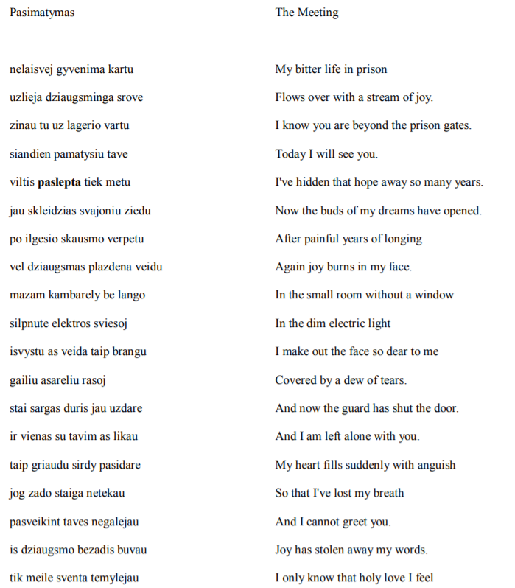
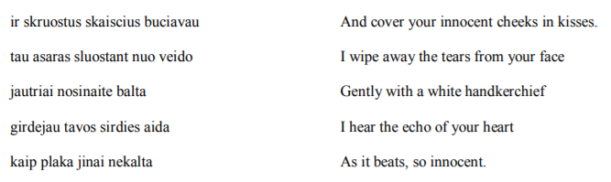
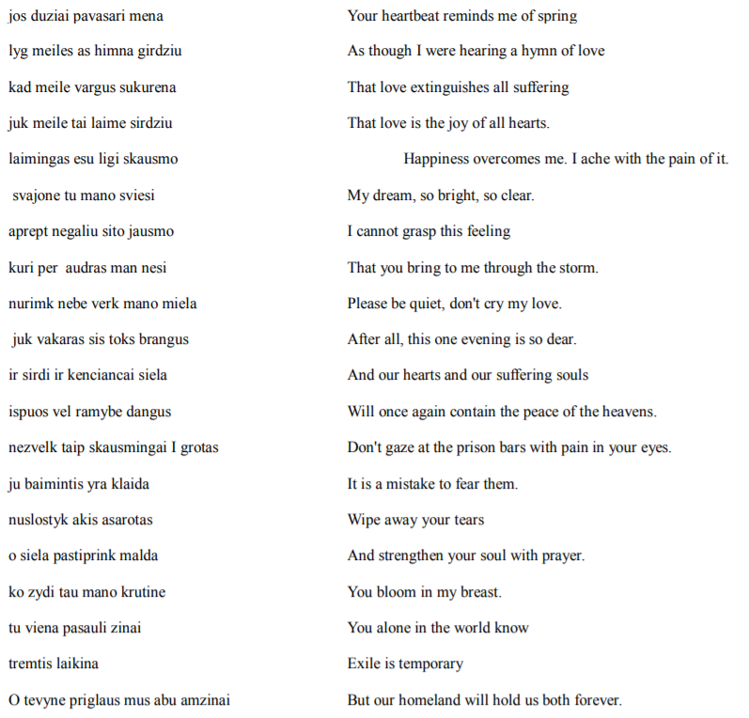

“Oh Jesus,” Ingrida sighed when Jonas Kadzionis finished the poem. The three of us took a
moment to reign in our emotions. I knew that once I got up from that table in this old partisan's house, my perspective on love would never be the same again. Kadzionis had shown me what it really meant to love, how sacred the feeling was, how uncompromising.
“In total she visited 16 times over the 25 years I was in prison,” Kadzionis said.
“How long were you allowed to visit with each other?” Ingrida asked.
“At first they gave us seven days and relieved us of our work. Sometimes they gave us two days or just one day. The rules would change year to year. They would give us a key to room, but the guard
would come and check at any time. Not only did they listen to us, but they'd watch us through a hole in the wall and a hole in the ceiling.
“While I was in prison, they would tell me that if I signed a statement saying that I’d made a
mistake, they’d let me go. But I wouldn’t sign. I could not lie to myself or anyone else.
“I served my full 25 year sentence and they released me in 1978. The KGB brought me a suit and
told me to put it on. I told them that I was comfortable traveling in my prison clothes. I’d lived and
worked in my prison clothes for 25 years, I told them, and I wanted to go home wearing them. What did I have to hide? I was proud to be a prisoner. I did not feel any inclination to pretend I was anything else.
In the end, they gave in. That was my protest: I was not going to cover anything up for them.
“The entire train ride home, people looked at me suspiciously; soldiers checked me out. The
militia arrested me in the Belarus train station in Moscow. They dragged me to the KGB. I had all my
documents. They made me tear off the pocket off with my number. They made me show my documents.
It was hidden from the militia that there could be any sentence longer than 15 years in the Soviet Union.
When they saw in writing that I'd served 25 years, they were shocked.
“They made a few phone calls to my place of imprisonment and then they told me I could go.
'No,' I said, 'you picked me up, now you take me back to where you took me from.' So they brought me back to Belarus Station. People on the train were good to me. They bought me beer. They could not believe that I'd served a full 25 years as a prisoner of conscience. The people in my coupe just kept shaking their heads, saying, “Bozhe Moy, 25 years.”
“But that was not the end of it. The KGB released me with the goal of getting me to inform for
them. They censored our letters and they knew my wife and I got along nicely, that we loved each other.
So, they thought they'd let me get cozy with her and then they'd get me to inform for them. They would tell me, 'Even the priests work for us.' I thought they were lying. Now I know that it was actually true,”
Kadzionis said and laughed, shaking his head back and forth in bewilderment.
“They wanted to kill me and my wife, when I wouldn't give in. My mother had died a year ago.
We came back for the anniversary. They were waiting for us. It was the end of May. My wife and I
came. We went to take a nap in the hay in the barn. At the same time the two of us began to scream in our sleep. We sat in the hay and analyzed our dreams. It turned out we'd both dreamed the same dream that they wanted to kill us. We knew many people who'd been killed. Pushed under cars. We then decided to leave.
“So, I hid from them. I wrote a letter to Moscow that I was hiding from the renegade Communist
Party in Lithuania. The Lithuanian Communists wouldn't let me register to live and work, I wrote to
them. The English government sent us an invitation to go live in England, but they wouldn't issue us
passports. My wife and I had to go into hiding.
“Eventually, we ended up going to live in the Kaliningrad region. The Lithuanians were a ruined
nation. The Latvians were not as corrupt as the Lithuanians. They would take in political prisoners. The Lithuanians were terrible. It's horrible now that the files are open to see how many of us were informing on each other.
“We returned from Kaliningrad in 1989 during the Singing Revolution when it was announced
that everyone who had lost the right to live in Lithuania had the right to return. We found a place to live in a rectory. Eventually, I was able to get the family land back and I returned home. My wife died in 1992. As she was dying, our grandson sat beside her bed and cried. Malvina told him, 'Please don't cry for me.' She comforted him even as she lay dying. That is the type of person Malvina was.
“We received our independence, but the half century of occupation has done a lot of harm to this
society. This is not the independence that we all imagined, but the fact that we have it is a miracle. People complain about life in independent Lithuania, but it is not independence that has brought all the problems. Those problems are carried over from the occupation.”
“Have you ever gone back to Siberia?” I asked.
“Last summer I returned to my place of imprisonment. I'm embarrassed to admit that I felt sad to
leave the place that I had wanted to leave so badly. It was a very good feeling to go back there. It feels good to go back to a place where you’ve done good works. You see, everything depends on a person's will. It's been said that without us prisoners of conscience there would have been no independence. Your will is important. And it is important not to give in. You can do nothing in life, but if your will is for good, then you've still done good works. How can one person possibly overthrow a tyrant like the Soviet Union? You can't. But what you can do is not give in.
Jonas Kadzionis ended our talk that day with one last poem:

